**Lab 6: *Accounts, Accounts Everywhere* (2%)**

**Name: Khai Phan Student Number: 100901164**

**Results**

**Part 1: Am I Cracked?**

* **Pwned Account**

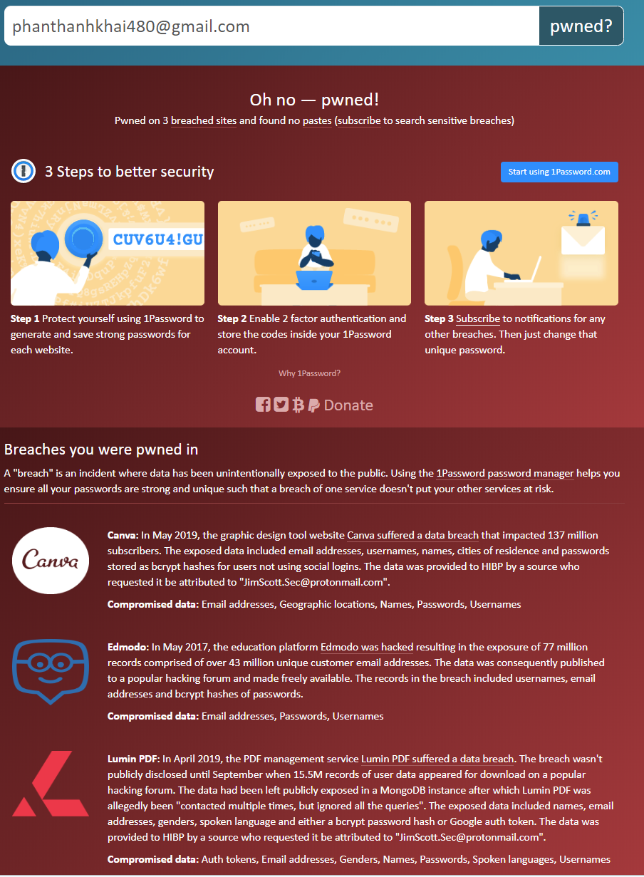

* **No pwn**

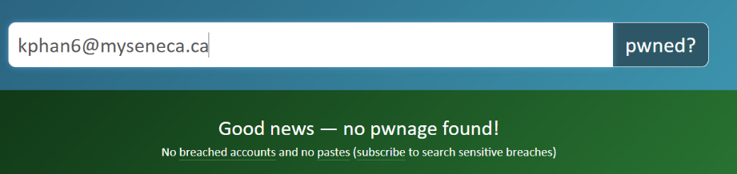

**Part 2: Integrity Checking**

* When download a software, the author usually provide a MD5 Checksum code to user so they can compare after downloaded to see if any malicious software have been added while downloading.
* Some of the time, the software is being distributed on a 3rd party website and they usually add a malicious software in for scamming purpose. By checking the hashsum from the orginal website, we can sure about the integrity of the data and know if it is safe to install.

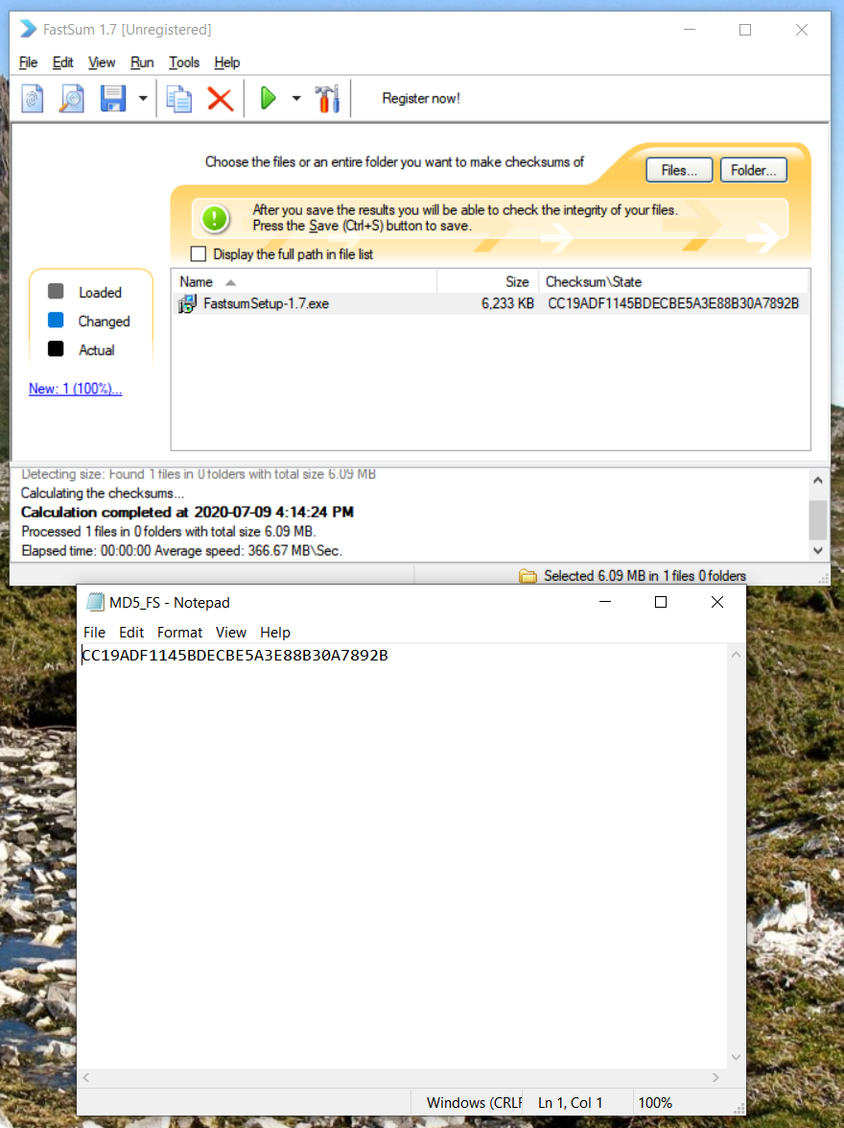

**Part 3: Creating User Account**

* MSU_passwd

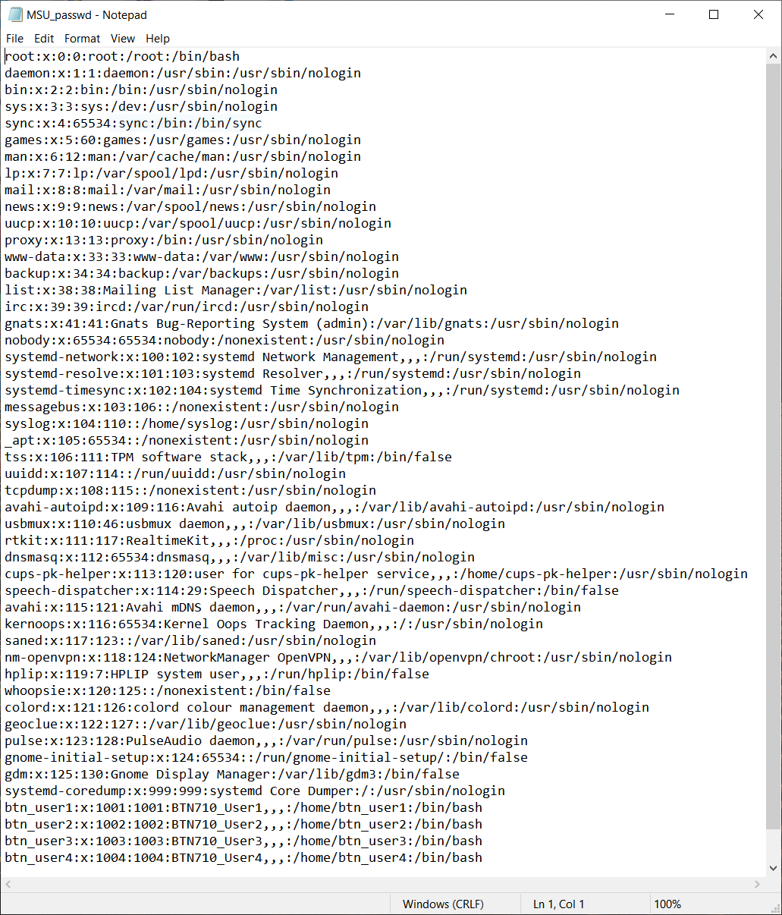

* MSU_shadow

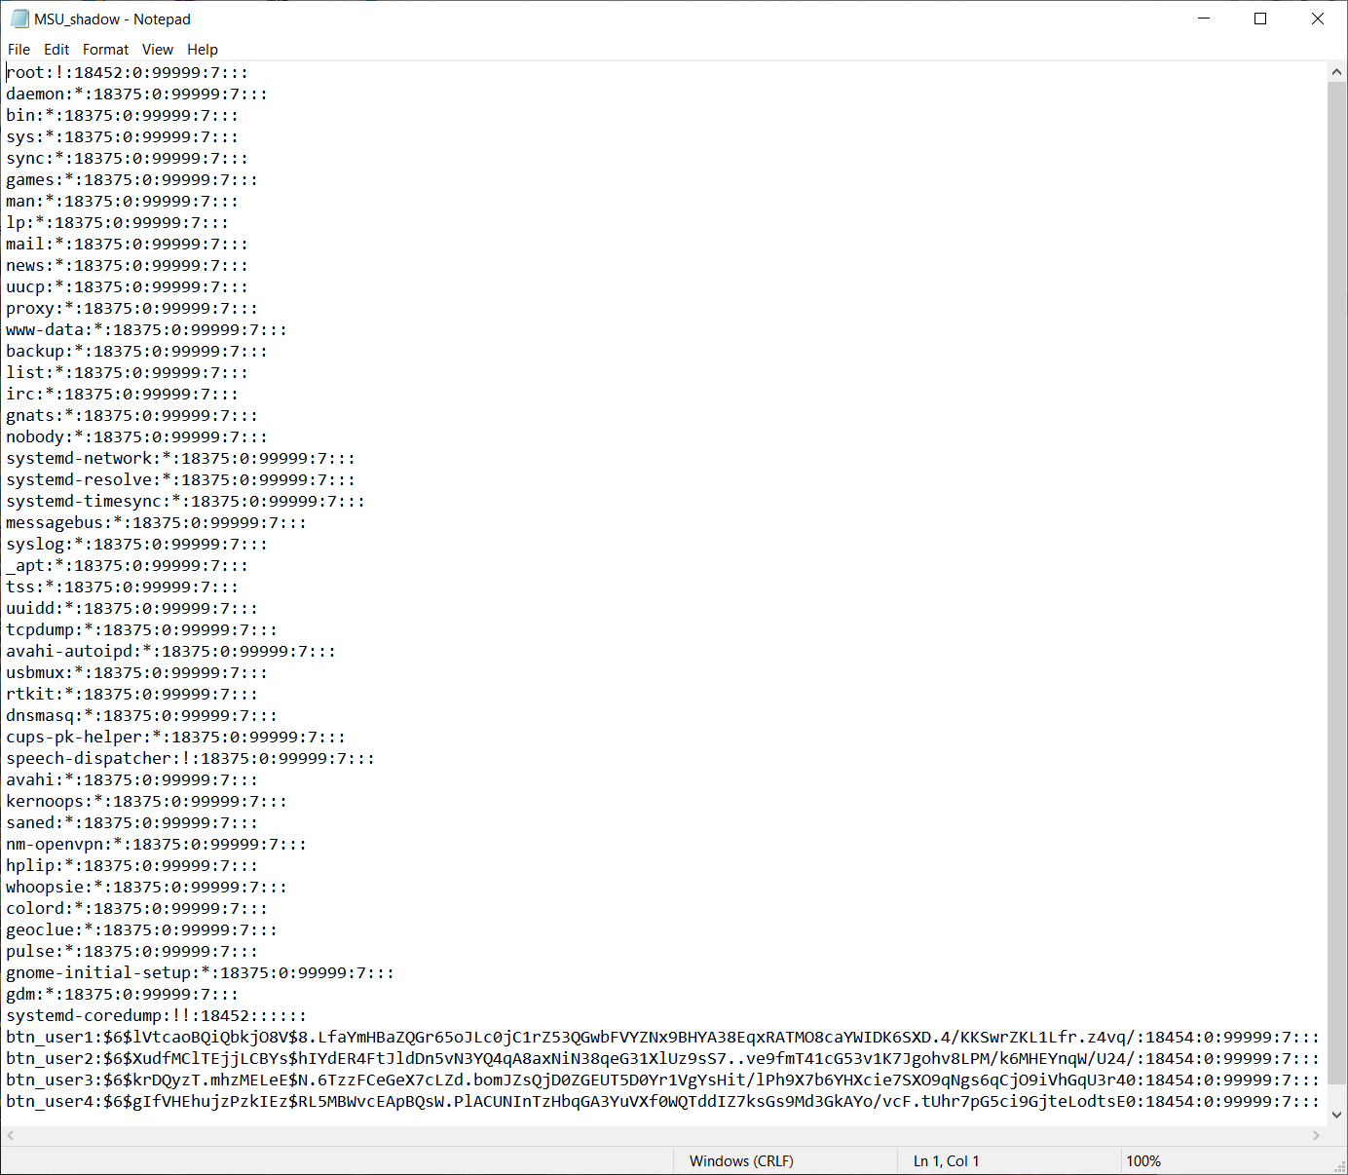

**Part 4: Cracking the password**

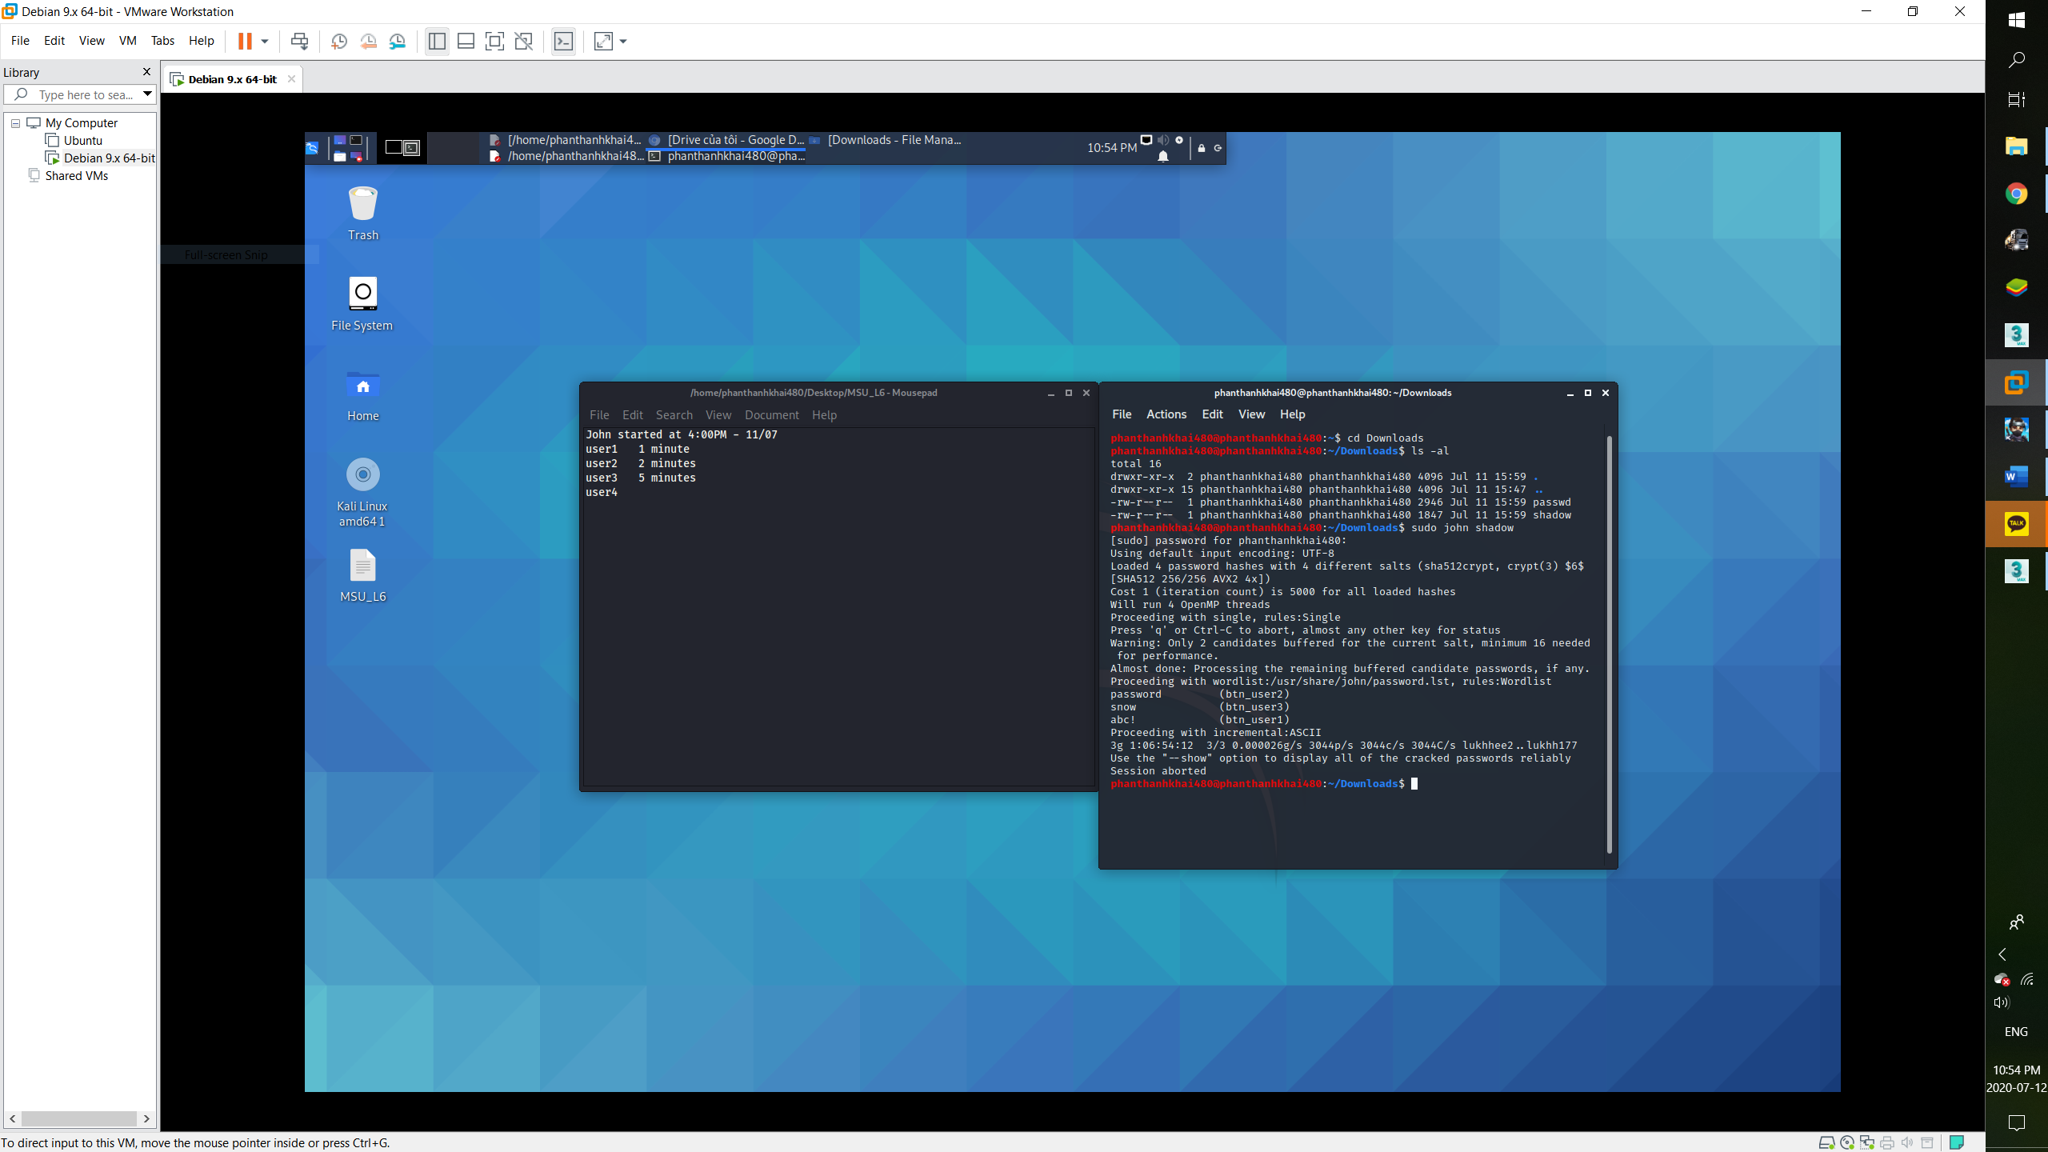

* *For the first 3 users, john was able to crack it within 5 minutes. On the last one (BTN710_User4 -qwas21), it took the machine almost 1 day and 10 hours and it couldn’t crack it. I would give it more time but it is close to the deadline of this so.*